Egyptian E-Learning University

Faculty of Computers & Information Technology

  - Waste2Taste
By
Yousef Mahmoud Malek | 2202282
Ahmad Ayman Albatanony | 2202231
Mennatallah Moustafa Ali | 2200108
Fares Hamza Mahmoud Hamza | 2202390
Abdelaziz Sameh Abdelaziz Ahmed | 2202361
Mohamed Yousry Sayed Ahmed | 2202430
Saad Salah Ahmed Nagy | 2202340
Mohamed Walied Baza | 2001885

  - Supervised by
Professor. Khaled Tawfik
  - Assistant
Eng. Soaad Mustafa

[Menoufia]-2025

Abstract
Food waste in Egypt has reached critical levels, with approximately 18 million tons discarded annually and 40% originating from food service and retail sectors. Despite the significant economic and environmental costs, there is currently no organized digital solution addressing this issue in the Egyptian market. This project proposes a Food Rescue Platform, a mobile application that enables vendors to sell near-expiry food at discounted prices rather than discarding it, transforming waste into opportunity.
The platform addresses a dual challenge by providing vendors with a revenue recovery mechanism for products that would otherwise represent total loss, while simultaneously offering customers access to quality food at reduced prices. This approach proves more practical than traditional donation models, as it incentivizes vendor participation through financial benefit while still supporting charitable distribution through optional features. The platform will be developed as an Android application with a web-based administrative panel, featuring geolocation-based vendor discovery, secure payment integration, and a multi-tier account system supporting vendors, customers, charities, and moderators.
To ensure food quality and platform integrity, the system incorporates AI-powered spoilage detection through image analysis and sentiment analysis of user reviews. A competitive analysis of existing international platforms revealed that AI-driven features are largely absent in the current market, presenting a significant opportunity for differentiation. This project demonstrates how technology can effectively address food waste at the retail level while creating measurable economic, social, and environmental benefits.

Acknowledgments
We would like to express our sincere gratitude to all those who contributed to the successful completion of this project.
First and foremost, we extend our deepest appreciation to our supervisor, Dr. Khaled Tawfik for their invaluable guidance, continuous support, and insightful feedback throughout the development of this project. Their expertise and encouragement were instrumental in shaping our work.
We are also grateful to our teaching assistant, Eng. Soaad Mustafa, for their technical assistance, practical advice, and dedication in helping us overcome the challenges we encountered during implementation.
Our thanks extend to the Egyptian E-Learning University, Faculty of Information Technology, for providing the resources and environment necessary for this research and development work.
We acknowledge the Food and Agriculture Organization (FAO) and World Population Review for providing comprehensive data on food waste statistics that informed our research and problem analysis. We would also like to thank our colleagues who participated in testing our platform and provided valuable feedback during the development process.

Contents
Abstract 2
Acknowledgments 3
Introduction 5
Literature Review / Related Work 7
Proposed system 9
Implementation 11
Testing & Evaluation 13
Results & Discussion 15
Conclusion & Future Work 17
References 19
Appendices 21

Chapter 1

Introduction

1.1 Introduction
Food waste represents one of the most pressing yet under-addressed challenges in Egypt's urban landscape. With approximately 18 million tons of food discarded annually, the country ranks among the highest per capita food-wasting nations globally. While this issue affects economies, communities, and the environment worldwide, Egypt faces unique challenges in addressing it due to limited awareness, inadequate infrastructure, and the absence of widely adopted digital solutions. This project proposes a Food Rescue Platform designed to connect food vendors with customers, transforming surplus food into economic opportunity while reducing waste at the retail and consumer levels.

1.2 Background and motivation
The motivation for this project emerged from collaborative discussions among our group seeking to identify a meaningful problem in Egypt within their technical scope and capabilities. During the problem identification phase, food waste stood out as a critical issue that lacked effective technological solutions in the Egyptian market. Although similar platforms exist internationally, such as Too Good To Go, and limited local attempts have been made through apps like Kasbanah and Mystery Bag, these solutions have failed to gain significant traction in Egypt, with download counts remaining barely above 10,000 users despite positive public reception.
Research into existing platforms revealed that while the concept of food rescue apps is well-received by the Egyptian public, as evidenced by enthusiastic responses to entrepreneurial pitches on platforms like Egyptian Shark Tank, awareness remains critically low. The gap between public interest and actual adoption suggested that the problem was not the viability of the solution itself, but rather the lack of effective implementation and market penetration. This observation formed the foundation for developing a more comprehensive and strategically positioned platform.

1.3 Importance of the problem
Food waste in Egypt extends beyond environmental concerns to create significant economic and social challenges. The national economy suffers substantial losses, with food service and retail sectors accounting for approximately 40% of total waste. Small food vendors, who operate on narrow profit margins, bear the direct financial burden of discarding unsold inventory. Charities and organizations serving low-income populations face the challenge of food insecurity while surplus food is simultaneously being discarded across the city.
From an environmental perspective, organic waste contributes significantly to the unsanitary conditions observed in urban areas. While a single application cannot eliminate Egypt's waste management challenges, reducing food waste would directly address one of the most problematic aspects of urban refuse: the rapid decomposition and odor associated with rotting organic matter. This improvement would contribute to better sanitary conditions in areas where waste accumulation is common.
Beyond practical considerations, food waste carries cultural significance in Egypt. Islamic principles, which deeply influence Egyptian society, emphasize respect for food and discourage wastefulness. This cultural context provides an additional dimension to the problem, as reducing food waste aligns with widely held religious and ethical values.

1.4 Problem Statement
Despite the scale of food waste in Egypt and the availability of technological solutions internationally, the problem remains largely unaddressed in the local market. The primary barriers are not technical but rather systemic: lack of awareness among both vendors and consumers, insufficient platform visibility, and absent coordination mechanisms between stakeholders.
Existing platforms such as Kasbanah and Mystery Bag have demonstrated proof of concept but failed to achieve market penetration. Vendors remain unaware of these solutions, and consumers who might benefit from discounted food products have no knowledge that such services exist. This awareness gap perpetuates a cycle where food continues to be discarded not due to lack of alternatives, but due to lack of information about available options.
Additionally, many consumers perceive near-expiry food as undesirable without understanding that such products remain safe and nutritious when properly handled. This perception, combined with vendors' reluctance to donate food due to logistical challenges and lack of financial incentive, creates a situation where economically viable food is routinely discarded. No significant legal or regulatory barriers prevent the sale of near-expiry food; the challenge is purely one of coordination, awareness, and market adoption.
The core problem this project addresses is: How can technology effectively connect food vendors with customers to reduce waste, recover economic value, and improve resource utilization in Egypt's retail food sector?

1.5 Objectives
Main Objective
To develop and demonstrate a viable Food Rescue Platform that reduces food waste in Egypt's retail sector by creating a digital marketplace connecting vendors with surplus food to customers seeking affordable options.
Specific Objectives
Technical Development:
1) Design and implement a functional Android mobile application providing customers with intuitive access to nearby food rescue opportunities
2) Develop a web-based administrative panel enabling vendors, NGOs, and system moderators to manage listings, transactions, and platform operations
3) Create a robust backend system incorporating database management, user authentication, payment processing, and RESTful API architecture
4) Integrate AI-powered features including image-based spoilage detection and sentiment analysis of user reviews to maintain food quality standards
Platform Features:
1) Implement geolocation-based vendor discovery allowing customers to find nearby participating outlets
2) Develop a multi-tier account system supporting distinct user roles: customers, vendors, charities, moderators, and corporate chains
3) Allow NGO integration by allowing users to register as users requiring assistance and get certified by the respective NGOs
4) Create a rating and review system enabling quality control through community feedback

1.6 Brief overview of the proposed solution.
This project proposes a comprehensive Food Rescue Platform addressing the food waste problem through financial incentive rather than relying solely on charitable donation. International success stories such as Too Good To Go demonstrate that vendor participation increases significantly when platforms offer revenue recovery rather than expecting pure altruism. Vendors receive payment for products that would otherwise represent total loss, creating a sustainable business model that encourages ongoing participation.
The platform introduces several mechanisms that enhance its appeal beyond simple discounting. The "mystery box" model, where customers purchase surprise assortments of surplus food, adds an element of excitement and gamification to the experience. This approach has proven successful internationally in maintaining customer engagement and repeat usage. Additional gamification elements, such as vendor leaderboards recognizing top food rescuers, may be explored to further incentivize participation and create community recognition.
The solution targets major Egyptian cities where smartphone penetration is high and residents are already familiar with delivery and marketplace applications such as Talabat. However, unlike delivery platforms, this system requires customer pickup at vendor locations, simplifying logistics and reducing operational costs. The platform will be technically available nationwide, allowing organic expansion as awareness grows beyond initial urban markets.
By combining vendor financial incentive, customer value proposition, charitable partnership options, and AI-powered quality assurance, this platform addresses the multifaceted nature of food waste while creating a sustainable ecosystem that benefits all stakeholders
Chapter 2

Literature Review / Related Work

2.1 Food Waste Management Technologies
The global challenge of food waste has prompted the development of various technological solutions aimed at connecting surplus food with consumers. These platforms represent a growing sector within the broader sustainability technology landscape, each approaching the problem from different angles while sharing the common goal of reducing waste and creating economic value.

2.1.1 International Food Rescue Platforms
Too Good To Go stands as the current market leader in food rescue applications, demonstrating the viability and scalability of the surplus food marketplace model. As of 2022, the platform had grown to over 57.7 million users and 154,000 partner establishments, successfully rescuing 139 million meals from waste. The platform's success stems from its "surprise bag" model, where customers purchase mystery boxes of surplus food at approximately one-third of the original price. In 2023 alone, Too Good To Go saved over 100 million meals in the UK, representing a 46 percent increase from the previous year. The platform's expansion across 20 countries demonstrates the universal applicability of the food rescue concept, though notably, no presence exists in the Middle East or North Africa region.
Olio represents a distinct approach within the food rescue ecosystem by focusing on consumer-to-consumer (C2C) sharing rather than business-to-consumer transactions. The platform has grown to 8 million users globally and distinguishes itself through its community-driven model where neighbors share surplus food and household items freely. Olio's "Food Waste Hero" program enables volunteers to collect unsold food from local businesses and redistribute it through the app, creating a hybrid model that combines commercial and charitable approaches. This community focus has proven effective in building engagement, with the platform reporting that two-thirds of users experience improved mental health and sense of connection through participation.
Karma, a Swedish platform founded in 2016, takes a more selective approach by allowing businesses to list individual surplus items rather than mystery bags. The platform has rescued 1,200 tons of food and more than 4 million meals, operating primarily in Sweden, the UK, and France. Karma reported raising $16.7 million in funding and growing to over 1 million users, positioning itself as a significant player in the European market. The platform's item-by-item listing approach provides more granular data on food waste patterns, enabling better predictive analytics and waste prevention strategies.

2.1.2 Egyptian Food Rescue Initiatives
Egypt's food rescue technology landscape remains in early development stages, with limited platforms achieving significant market penetration despite strong conceptual reception.
Tekeya, launched in 2019 by Menna Shahin, represents Egypt's pioneering effort in food waste technology. The platform connects restaurants with consumers, allowing meals to be purchased at half price or donated to charitable organizations. The app includes an AI-powered system to help restaurants calculate food waste and receive suggestions for reduction. However, despite early promises and expansion to multiple governorates, Tekeya has struggled with adoption challenges. The platform faces stigma associated with "leftover food," with consumers often presuming such food has gone bad, highlighting cultural barriers unique to the Egyptian market.
Kasbanah, founded by Youssef Nour after encountering similar platforms while studying in the UK, has achieved more substantial traction. The platform now boasts over 150,000 users and operates a "Secret Bag" model similar to Too Good To Go's surprise bag concept. Kasbanah's homegrown approach and focus on the Cairo market demonstrates that adapted international models can achieve meaningful adoption in Egypt when properly localized.
Mystery Bag represents the most recent entry into Egypt's food rescue market, appearing after initial competitive analyses were conducted. The platform employs a similar surprise bag model and has begun building partnerships with restaurants and stores across Cairo. As a newer entrant, download counts remain modest, though the platform benefits from lessons learned by earlier Egyptian attempts and incorporates modern app development practices.

2.2 Artificial Intelligence in Food Waste Management
While AI applications in food waste management have advanced significantly in industrial and commercial settings, their integration into consumer-facing food rescue platforms remains largely unexplored, representing a significant gap in current solutions.

2.2.1 AI for Spoilage Detection
Research has demonstrated AI's effectiveness in identifying food spoilage through computer vision and sensor integration. CNN models for fruit and vegetable type detection, combined with gas emission, humidity, and temperature monitoring, have achieved 95% accuracy rates in spoilage detection. AI-driven solutions from companies like Shelf Engine and Afresh have shown a 14.8% reduction in food waste per store, with IKEA achieving a 30% reduction in kitchen food waste within one year using AI-powered monitoring. However, these systems typically operate in controlled commercial environments with dedicated hardware infrastructure, making direct implementation in consumer marketplace apps challenging.

2.2.2 Predictive Analytics and Demand Forecasting
AI's role in waste prevention through predictive analytics has shown promising results in retail and restaurant settings. Modern AI systems analyze historical sales, seasonal trends, promotions, and local considerations like weather or events to recommend precise production quantities, addressing waste at its source. Platforms like Leanpath and Winnow utilize track-discover-drive methodologies combined with AI-enhanced coaching tips to help establishments identify waste sources and take actionable steps. These predictive capabilities, when applied to food rescue platforms, could enable vendors to list surplus items proactively rather than reactively, improving both efficiency and food quality.

2.2.3 Sentiment Analysis and Quality Control
AI-powered sentiment analysis offers potential for maintaining platform quality through automated review monitoring. Machine learning algorithms can analyze consumer behavior patterns and provide insights for tailoring offerings while minimizing waste. In the context of food rescue platforms, sentiment analysis could identify problematic vendors, detect fraud patterns, and ensure consistent quality standards across listings without requiring extensive manual moderation.

2.3 Gap Analysis and Identified Opportunities
A comprehensive analysis of five major international platforms (Too Good To Go, Kashrut, Olio, Karma, and Flashfood) reveals several critical gaps in current food rescue technology.

2.3.1 Absence of AI-Driven Features
The most significant finding from the competitive analysis is the complete absence of AI-driven personalization across all examined platforms. While AI has proven effective in commercial food waste management, no consumer-facing food rescue platform has successfully integrated predictive surplus forecasting, personalized recommendation engines, or dynamic pricing algorithms. This represents a substantial opportunity for differentiation, as AI could address multiple pain points simultaneously: improving vendor efficiency through waste prediction, enhancing customer experience through personalization, and optimizing platform economics through intelligent pricing.

2.3.2 Limited Delivery Options
Among the five analyzed platforms, only two (Kashrut and Olio) offer delivery options, with most requiring customer pickup. While pickup-based models reduce operational complexity, the lack of delivery limits accessibility for users without transportation and reduces convenience during adverse conditions. The gap between customer expectations set by mainstream food delivery apps and food rescue platform capabilities represents both a challenge and an opportunity.

2.3.3 Market Penetration in Developing Regions
International food rescue platforms have achieved significant success in Europe and North America but remain virtually absent from developing regions including the Middle East and North Africa. Egypt, despite ranking among the world's highest per-capita food waste producers, has seen limited platform adoption. The few existing Egyptian platforms (Tekeya, Kasbanah, Mystery Bag) collectively represent fewer than 200,000 users despite serving a metropolitan Cairo population exceeding 20 million. This gap suggests not just market opportunity but also potential challenges unique to developing economies that require tailored solutions.

2.4 Summary
The literature reveals a maturing food rescue technology sector internationally, led by platforms like Too Good To Go that have demonstrated both technical viability and business sustainability. However, significant gaps persist particularly in AI integration, where proven waste management technologies have not been adapted for consumer marketplace applications. The Egyptian market presents unique challenges including cultural perceptions of surplus food and limited digital payment adoption, but also represents substantial opportunity given the country's high waste rates and underserved urban populations. The convergence of these factors suggests that a platform combining proven international marketplace models with novel AI-driven features tailored to local market conditions could address unmet needs while differentiating from existing solutions.

Chapter 3

Proposed system

3.1 Approach Used to Solve the Problem
The Food Rescue Platform addresses food waste through a marketplace approach connecting food vendors with surplus inventory to customers seeking discounted food items.
Key components of our solution:
- Mobile and web applications enabling vendors to list surplus food at reduced prices
- Location-based discovery for customers to find nearby offerings
- AI-powered quality assurance through spoilage detection and sentiment analysis
- Integration with charity organizations for food assistance programs
This creates value for all stakeholders: vendors recover costs, customers access affordable food, charities support those in need, and the environment benefits from reduced waste.

3.2 System Architecture
3.2.1 Use Case Diagram
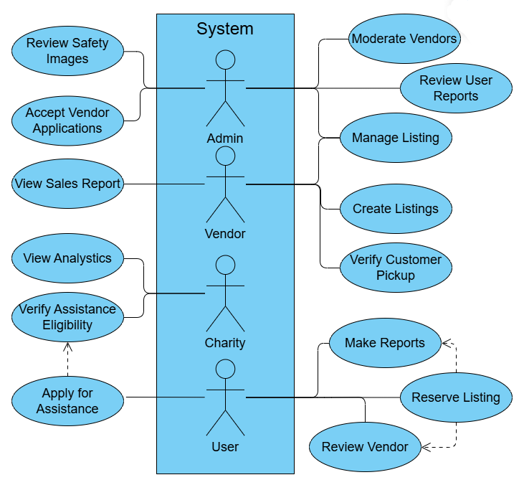
Figure 3.1: System Use Case Diagram showing actors (User, Vendor, Charity, Admin) and their interactions with the platform
3.2.2 Database Schema
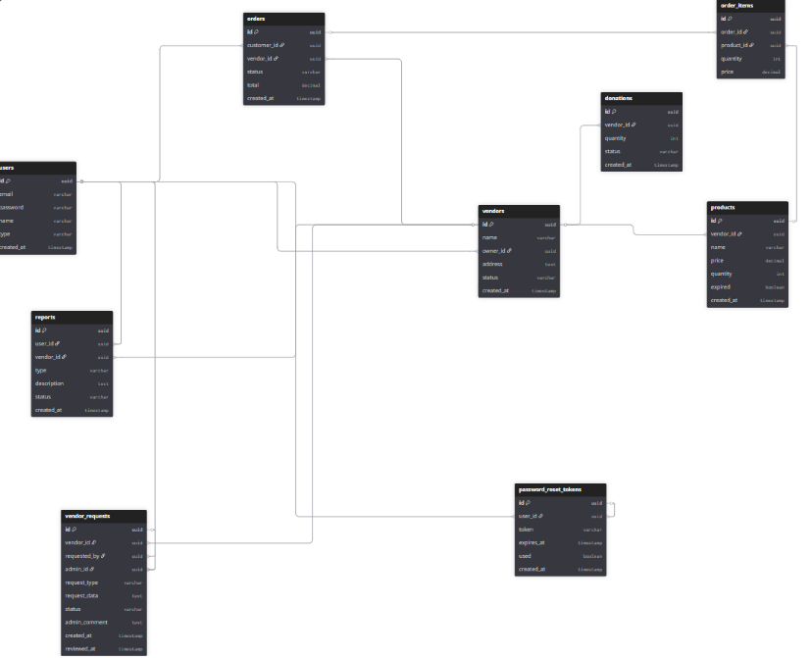
Figure 3.2: Database Schema showing entities (Users, vendors, products, Orders, OrderItems, Reviews, reports, Donations, PasswordResetTokens) and their relationships

3.2.3 Sequence Diagram (User purchase)
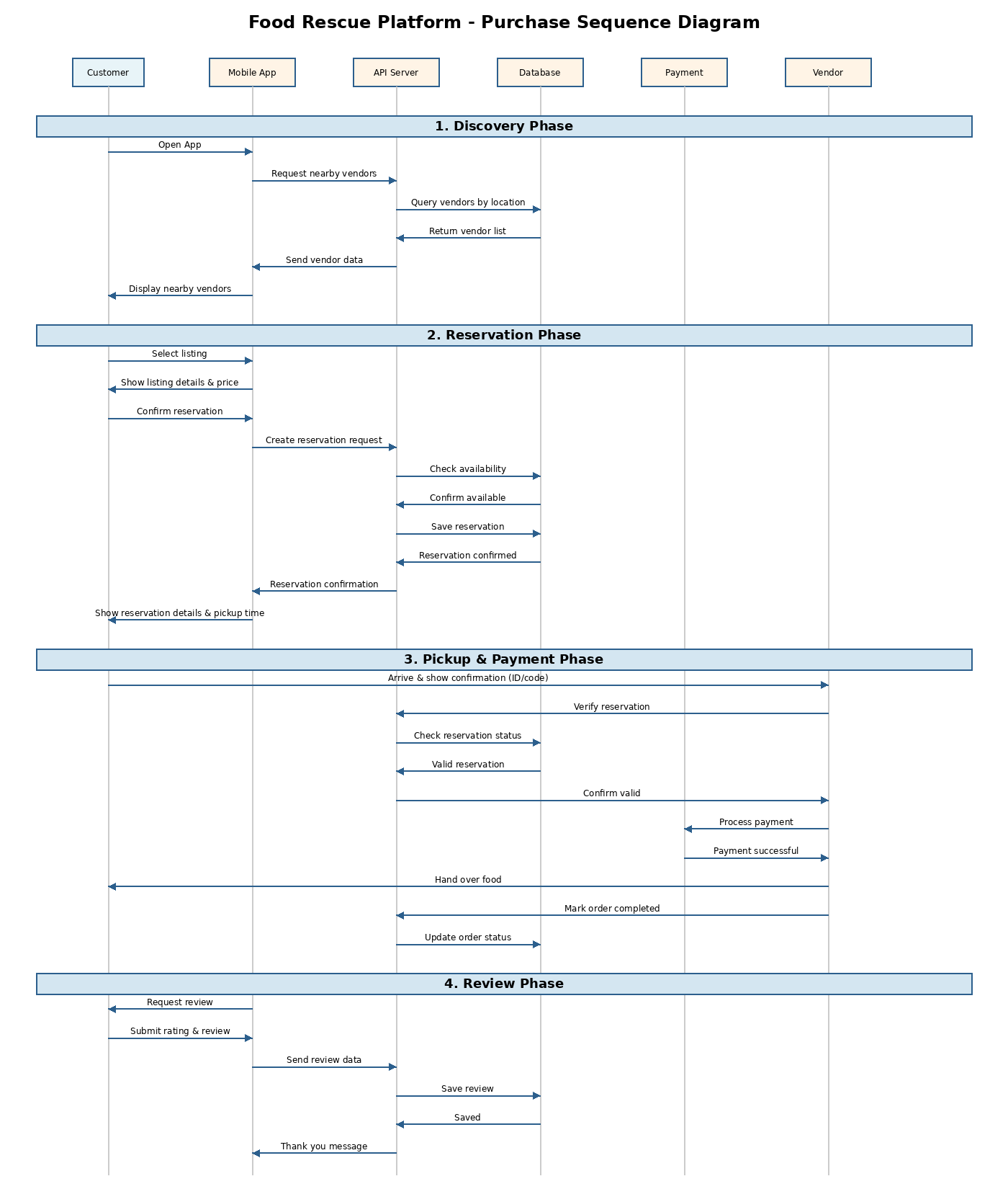
Figure 3.3: Purchase Flow Sequence Diagram illustrating the four-phase transaction process (Discovery, Reservation, Pickup & Payment, Review) between Customer, Mobile App, API Server, Database, Payment Gateway, and Vendor

3.3 Functional and Non-Functional Requirements
Functional Requirements:
- FR1: Users can browse and reserve food listings by location and price
- FR2: Vendors can create and manage listings with images and details
- FR3: AI detects food spoilage in uploaded images
- FR4: Sentiment analysis processes user reviews
- FR5: Payment physical through the vendor
- FR6: Admins can moderate vendors and review reports
- FR7: Charities can verify user eligibility for assistance

Non-Functional Requirements:
- NFR1: Support 1,000+ concurrent users
- NFR2: 99.5% uptime with automated backups
- NFR3: Mobile support for android 8.0+

3.4 Algorithms or Frameworks Used
Frontend (Admin View)
- React.js (Vite): Web frontend framework
- TypeScript: Strongly-typed JavaScript for safer development
- Tailwind CSS: Utility-first CSS framework for responsive UI
Mobile Application (User View)
- Flutter: Cross-platform UI framework for Android and iOS
- Dart: Programming language used for Flutter development
- REST APIs: Communication between mobile app and backend
Backend
- ASP.NET Core Web API: Backend RESTful services
- Entity Framework Core: Object-Relational Mapping (ORM) for database operations
- JWT Authentication: Secure user authentication and authorization
- 3-Layer Architecture:
  - Presentation Layer (API Controllers)
  - Business Logic Layer
  - Data Access Layer
Database
- SQL Server: Relational database management system
Development Tools
- Git: Version control for source code management
Work plan
Phase | Activity | Description | Status
Idea | Problem Identification | Check existing sources for details about the problem locally | Completed
Idea | Gap analysis | Review existing platforms with the same or similar concepts | Completed
Idea | Project Proposal | Define project idea and scope/details | Completed
Analysis | Requirements Gathering | Identify functional and non-functional requirements | Completed
Analysis | Use Case Analysis | Design a use case diagram for the stakeholders based on the proposal | Completed
Design | Database Design | Design relational database schema for backend | Completed
Implementation | Frontend Development | Develop user interfaces | Completed
Implementation | Mobile Development | Develop Mobile interface for users | Completed
Implementation | Backend Development | Implement backend | Completed
Implementation | AI Integration | Sentiment analysis and spoilage detection AI model | Completed
Testing | Functional Testing | Testing core features of the platform both on admin and user end | Completed
Documentation | Final Report & Presentation | Prepare final project report, diagrams, and presentation materials | Completed

Chapter 4

Implementation

4.1 Technologies, Tools, and Programming Languages Used
The Waste2Taste platform is built across four independently deployable components: a backend API, an AI microservice, a web admin panel, and a mobile application. Each component uses a technology stack suited to its role and constraints.

Backend API
The backend is built with ASP.NET Core Web API targeting .NET 8, using a three-layer architecture (Presentation, Business Logic, and Data Access). Entity Framework Core 8 handles all database interaction with SQL Server as the primary data store. Authentication is handled via JWT Bearer tokens with refresh token support, and ASP.NET Core SignalR is used for real-time push notifications to connected clients.
Package | Version | Purpose
Microsoft.EntityFrameworkCore.SqlServer | 8.0.0 | ORM + SQL Server driver
Microsoft.AspNetCore.Authentication.JwtBearer | 8.0.0 | JWT authentication
Microsoft.AspNetCore.SignalR | 1.2.9 | Real-time notifications
Mapster | 7.4.0 | Object-to-DTO mapping
FluentValidation.AspNetCore | 11.3.1 | Request validation
MailKit / FluentEmail.Smtp | 4.14 / 3.0 | Email delivery

AI Microservice
The AI service is a standalone Python application built with FastAPI and served via Uvicorn. It runs separately from the main backend and is deployed as a Docker container. Model inference uses ONNX Runtime (CPU mode), which allows the trained TensorFlow/Keras models to run without any GPU dependency. The sentiment analysis component uses a pre-trained multilingual transformer from HuggingFace Transformers.

Library | Purpose
FastAPI | REST API framework
ONNX Runtime | Spoilage model inference
Pillow + NumPy | Image preprocessing
Transformers (HuggingFace) | Zero-shot sentiment classification
TensorFlow / Keras | Model training (offline pipeline)
Uvicorn | ASGI production server
Training was done offline using scripts that download datasets via the Kaggle API, organize them by category, and run a two-stage MobileNetV2 transfer learning process before exporting to ONNX.

Web Admin Panel
The admin panel is a single-page application built with React 18 and TypeScript, bundled with Vite. Tailwind CSS handles styling. TanStack Query manages server state and automatic refetching, while Axios handles API requests. Charts for the analytics dashboard are rendered with Recharts, and maps use React-Leaflet.
Library | Purpose
React 18 + TypeScript | UI framework
Vite | Build tool
Tailwind CSS + Radix UI | Styling and accessible components
TanStack Query (React Query) | Server state management
Recharts | Analytics charts
React-Leaflet | Vendor map view
React Hook Form + Yup | Form handling and validation
jsPDF + jspdf-autotable | PDF export for reports

Mobile Application
The customer-facing mobile app is built with Flutter (Dart), targeting Android and iOS from a single codebase. State management follows the BLoC pattern using flutter_bloc. Navigation is handled declaratively with go_router. Location features use google_maps_flutter and geolocator, while secure storage of auth tokens is handled by flutter_secure_storage.
Package | Purpose
flutter_bloc | BLoC state management
dio | HTTP client
go_router | Declarative routing
google_maps_flutter | Map display + vendor discovery
flutter_secure_storage | Encrypted JWT storage
firebase_core | Firebase services
cached_network_image | Efficient image loading
flutter_localizations | Arabic / English UI

Development & Deployment Tools
Tool | Purpose
Git + GitHub | Source control and team collaboration
Visual Studio 2022 | Backend C# development
Swagger UI | API documentation and manual testing
Docker | Containerization of the AI service
Railway | Cloud hosting for the AI microservice
Vercel | Cloud hosting for the admin panel

4.2 Key Components/Modules of the System
The Waste2Taste platform is structured as a distributed network of modular systems. The architecture consists of a client-side layer (the customer-facing mobile application and the administrator web panel) and a server-side layer (the transactional ASP.NET backend and the Python FastAPI AI microservice).
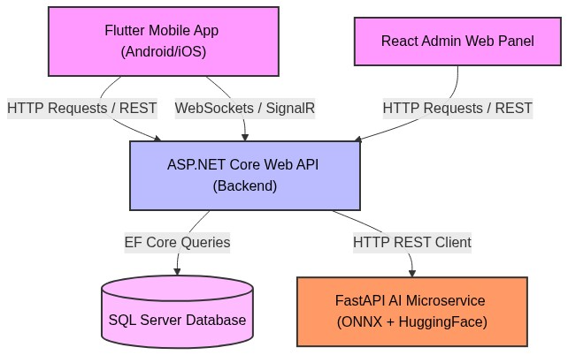

4.2.1 Backend Web API (ASP.NET Core)
The backend backend API is designed using a Clean 3-Layer Architecture pattern to isolate database mappings, core business logic, and interface controllers:
- Presentation Layer (FoodRescue.PL): Defines REST controllers, route handlers, error filters, and SignalR presence hubs.
- Business Logic Layer (FoodRescue.BLL): Houses business rules, logic services, custom data validation via FluentValidation, and objects/DTO mappers.
- Data Access Layer (FoodRescue.DAL): Governs the EF Core CompanyDbContext, database entity models, and schema configurations.
Backend Controllers & Logical Mapping
The C# backend hosts 18 API Controllers managing all features of the application:
Controller | Purpose | BLL Services / DTOs | Database Entities
AuthController | Registers, logs in, logs out, and refreshes tokens. | AuthService, RegisterDto, LoginDto | User, RefreshToken
UserController | Manages client profiles, list vendors, and account updates. | UserService, UserUpdateDto | User, Vendor
VendorsController | Handles public merchant views, locations, and updates. | VendorService, VendorProfileDto | Vendor
VendorRequests | Manages merchant registrations and onboarding approvals. | VendorRequestService | VendorRequest
Products | Allows adding, editing, listing, and filtering foods. | ProductService, ProductCreateDto | Product
Upload | Local disk storage file uploads for product/profile images. | FileStorageService | None (Direct IO)
ListingApproval | Evaluates and approves/rejects vendor product listings. | ListingDashboardTabService | Product
Orders | Executes reservations, tracking, and cancellation for users. | OrderService, OrderCreateDto | Order
VendorOrders | Allows merchants to accept, release, or cancel active orders. | OrderDashboardTabService | Order
Donations | Distributes surplus food items directly to registered charities. | DonationService, DonationCreateDto | Donation
Reviews | Collects buyer reviews, integrated with AI sentiment scoring. | ReviewService, CreateReviewDto | Review, SentimentAnalysis
Reports | Files and processes disputes against merchants or items. | ReportService | Report
Support | Submits customer issues and questions to admin staff. | HelpAndSupportService | None (Direct DB writes)
VendorDashboard | Feeds visual data endpoints for merchant control panels. | VendorDashboardService | Product, Order
VendorAnalytics | Outputs revenue summaries, saved weight, and metrics. | AnalyticsDashboardTabService | Order
VendorListings | Handles private merchant view of historical product listings. | ListingDashboardTabService | Product
ActivityLogs | Admin view of audit log events and critical actions. | LogsService | ActivityLog
AdminController | Controls system administration actions and statistics. | AdminService | All Tables

4.2.2 FastAPI AI Microservice
The AI Microservice acts as a decoupled gatekeeper deployed on Railway Cloud, written in Python. It performs asynchronous image evaluation and text parsing tasks:
- Ensemble Spoilage Detection Module (/predict):
  - Accepts image uploads via multi-part form parameters.
  - Loads optimized ONNX Runtime sessions to process image tensors.
  - Executes an ensemble classification strategy: it runs a generic classifier alongside a category-specific classifier (e.g. Bread, Dairy, Fish, Meat, Produce). The system computes confidence percentages and labels the item as Fresh or Spoiled based on the model with the highest confidence.
- Multilingual Zero-Shot Sentiment analysis (/sentiment):
  - Loaded with MoritzLaurer/mDeBERTa-v3-base-xnli-multilingual-nli-2mil7 (and optimized in production using MiniLMv2-L6 for high throughput).
  - Classifies customer inputs into 6 categories (gratitude, disappointment, disgust, frustration, excitement, urgency).
  - Employs lazy-loading initialization to avoid cold-boot resource depletion on Railway.
- Training & Conversion Pipeline:
  - Structured scripts that fetch raw datasets from Kaggle, apply data augmentations, train deep learning architectures (MobileNetV2 backbone), validate models, and translate them to ONNX models.

4.2.3 Web Admin Panel (React 18 + Vite)
The Admin web panel is built as a single-page client dashboard that provides the primary interface for system moderation and data visualization:
- Dashboard & Analytics Module (DashboardView.tsx):
  - Visualizes critical key performance metrics (active listings, total weight saved, overall revenue).
  - Generates interactive line and bar charts using Recharts to assist platform monitoring.
- Flagged Content Moderation Module (ModerationView.tsx):
  - Evaluates disputed listings, user complaints, and reviews flagged by the AI sentiment analysis.
  - Provides administrative controls to ban accounts, dismiss reports, or suspend products.
- Vendor Approval Panel:
  - Displays incoming merchant request applications and document attachments.
  - Grants business permissions and flags new vendor locations on the interactive map system.

4.2.4 Customer Mobile Application (Flutter)
The customer-facing application is built using Flutter and structured around distinct features in the lib/Features/ folder. State management is organized around BLoC Cubits:
- Map-Based Vendor Discovery (map/ / home/):
  - Employs google_maps_flutter overlay widgets to display nearest vendor locations.
  - Integrates the device geolocation sensor via geolocator to filter options dynamically by distance.
- Surplus Ordering & Reservation System (products/ / orders/):
  - Renders product cards with photos, countdowns, and stock details.
  - Implements localized cart caching and guides customers through the checkout reservation process.
- Report & Feedback module (report/):
  - Permits consumers to upload photos of items, evaluating fresh/spoiled status using the AI service, or submit text-based complaints.
- Multilingual Core (core/l10n/):
  - Full support for Arabic and English UI structures, respecting RTL constraints for Arabic layouts.

4.3 Challenges Faced and How They Were Resolved
During the development and deployment of the Waste2Taste platform, several technical and structural challenges were encountered across the AI pipeline, backend API, and mobile client. These challenges and their resolution strategies are detailed below.

4.3.1 Technical Challenges & Resolutions Summary
Component | Technical Challenge | Resolution Strategy | Impact
AI (Models) | Dataset class imbalance (e.g., Bread had 1,000+ spoiled but only ~200 fresh images). | Capped overrepresented classes and computed balanced class weights during training. | Prevented prediction bias and improved accuracy of minority classes.
AI (Deploy) | RAM spikes (~1.1 GB) on FastAPI container startup exceeding Railway's free-tier limits. | Implemented lazy-loaded HuggingFace pipelines, initializing on the first request. | Prevented cold-boot crashes and container terminations.
AI (Deploy) | Multilingual zero-shot inference latency too high for production API (681ms average). | Switched from mDeBERTa-v3 to optimized MiniLMv2-L6 Zero-Shot model. | Reduced average API latency to 56ms while retaining accuracy.
Backend | Database query overload when tracking online users and real-time connections. | Created an in-memory dictionary inside the SignalR PresenceHub to map connections. | Bypassed SQL Server queries entirely for checking active user counts.
Backend | Session Hijacking and Token Theft risks over public HTTP networks. | Implemented a dual-token JWT flow (short-lived access token + DB-stored refresh token). | Secures user sessions without requiring frequent logins.
Mobile | Geolocation permission rejection causing app crashes when trying to render vendor maps. | Gracefully caught location errors and fell back to default coordinates. | Kept app responsive and interactive even without GPS permission.
Mobile | High cellular data consumption and latency when loading vendor list images. | Integrated cached_network_image to store vendor logos locally on disk. | Substantially reduced network requests and speed up UI loading.

4.3.2 Detailed Resolutions
1. Machine Learning Dataset Imbalance & Image Corruption
In the data preparation stage, training category-specific classifiers (such as Bread) resulted in poor validation accuracies due to extreme class imbalances. To solve this, the pipeline was rewritten to enforce a ceiling of 600 images per class and dynamically compute class weights in Keras:
1. class_weights = class_weight.compute_class_weight(
2. 'balanced',
3. classes=np.unique(train_generator.classes),
4. y=train_generator.classes
5.)
Additionally, during the processing of over 100,000 images, standard PIL decoders threw OSError: broken data stream on corrupted JPEG files. This was solved by configuring:
1. from PIL import ImageFile
2. ImageFile.LOAD_TRUNCATED_IMAGES = True

2. Cloud Server Memory Limits & Execution Latency
Deploying transformer models inside serverless Docker instances presented memory limitations. The mDeBERTa-v3 model loaded standard weights into memory on startup, causing the Docker container to exceed Railway's RAM allocations and crash. By wrapping the pipeline initialization inside a lazy-load singleton helper, memory allocation is deferred until a client actually triggers /sentiment:
1. def get_sentiment_classifier():
2. global sentiment_model
3. if sentiment_model is None:
4. load_sentiment_classifier()
5. return sentiment_model
To further optimize performance, switching to multilingual-MiniLMv2-L6-mnli-xnli compressed the model footprint and decreased query latency from 681ms to 56ms.
3. Real-Time SignalR Memory Optimization
In typical SignalR setups, tracking when users connect and disconnect to update store listing counts requires constant updates to the database. To protect the database from connection floods, a thread-safe static dictionary mapping was implemented in the:
1. private static readonly Dictionary<string, string> OnlineUsers = new();
This manages user presence mapping in server RAM and only issues database updates when necessary, optimizing CPU utilization.

Chapter 5

Testing & Evaluation
To ensure that the Waste2Taste platform functions reliably, handles concurrent user interactions securely, and delivers accurate machine learning predictions, a comprehensive testing and evaluation framework was established. This chapter details the testing strategies applied across all system layers, highlights the performance and accuracy metrics of the AI classifiers, and compares the final system against prominent existing market solutions.

5.1 Testing Strategies
The testing strategy follows a multi-tiered approach designed to validate the system at different levels of granularity. The testing lifecycle spans from isolated code verification to automated integration testing, culminating in manual User Acceptance Testing (UAT) to validate real-world business flows.

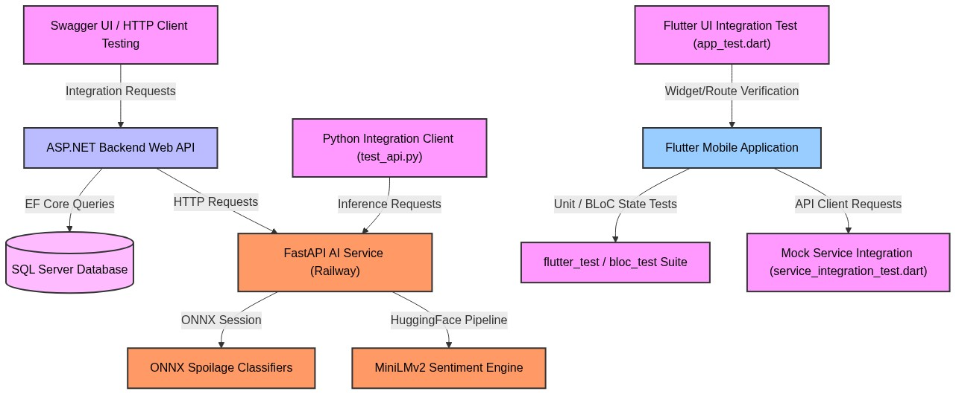5.1.1 Unit Testing
Flutter Mobile Application Unit Testing
- Target Framework: flutter_test for widget/utility assertions, bloc_test for Cubit state management sequences, and mocktail for dependency mocking.
- Scope: Covers 16 comprehensive test suites targeting state machines, network adapters, and local helper utilities:
  - Cubit / State Management Testing:
    - LocalizationCubit: Verifies that language codes default to 'en', load properly from local settings (PrefsService), and persist correctly upon language updates (LocalizationChanged).
    - ThemeCubit: Asserts that theme switches change state values and persist selections.
    - LoginCubit: Validates that entering valid credentials triggers onboarding, and that login errors are handled elegantly.
    - GetProductsCubit & ReserveOrderCubit: Asserts proper progression of loading, success, and error states when listing or ordering products.
    - OnboardingCubit: Validates onboarding navigation page transitions.
  - Repository & Data Source Layer Testing:
    - AuthRemoteDataSourceImpl & AuthRepoImpl: Verifies that API interactions serialize/deserialize login, signup, email verification, and password reset requests. Uses mocktail to intercept Dio requests and verify correct parsing of standard 200 responses as well as bad request and connection timeout failures.
  - Utility & Domain Helper Testing:
    - AppRegex: Validates the regular expression logic for email addresses, Egyptian phone numbers, and names.
    - ServerFailure: Confirms that HTTP bad responses and connection exceptions map into user-friendly error messages.
    - calculateDistance: Verifies the Haversine formula calculation for finding the exact physical distance between user geolocations and merchant pins.
    - formatPickupTime, orderStatusMapper, and uiMappers: Checks formatting, status mapping, and model conversions.

5.1.2 Integration Testing
Integration testing ensures that separate modules and external services communicate correctly. The following integration pathways were tested and verified:
1. Backend REST API & Database Integration
Instead of manual UI clicking, the ASP.NET Core API was verified programmatically using the built-in Swagger UI (Swashbuckle) and a Visual Studio Code REST Client (FoodRescue.PL.http).
- Test Case Example (JWT Refresh Token Lifecycle): A script issues a request with an expired access token to a protected endpoint. It verifies that the API returns HTTP 401 Unauthorized. The script then requests /auth/refresh-token with the refresh token. It validates that the response contains HTTP 200 OK alongside a new rotated access token, allowing the original request to be re-sent and succeed.
- Database Constraints: Verified database transactions and key constraints in SQL Server via Entity Framework migrations. For example, testing cascading delete limits on entities: deleting a user must trigger the removal of their active refresh tokens, but reports submitted by that user are retained as anonymous records by using DeleteBehavior.Restrict or DeleteBehavior.SetNull to prevent database inconsistency.
2. AI Microservice & Backend Communication
The FastAPI AI service was tested using an integration script (test_api.py):
- Image Prediction route (/predict): The script uploads sample fresh and spoiled images via multipart form data, verifying that the FastAPI server successfully executes ONNX sessions and returns JSON payloads containing the predicted label, confidence, and a boolean is_spoiled flag.
- Text Sentiment route (/sentiment): Verified that Arabic and English customer review strings sent to the AI service are correctly classified into the appropriate sentiment categories (e.g., mapping "الخبز كان مقرفًا" to disgust).
3. Flutter Mobile Application UI Integration Testing
- Target Framework: integration_test (Flutter's official integration test library).
- Scope: Automated interface widget and router integration tests executed in mobile/food_rescue_app/integration_test/app_test.dart.
- Key Scenarios Tested:
  - Splash Display & Timeout: Verifies that launching the app presents the brand text elements (Waste, 2, Taste). Simulates a virtual clock advance of 4 seconds to ensure the router correctly shifts to the OnboardingView.
  - Onboarding Navigation: Taps the onboarding next button twice and then clicks "Get Started" to ensure smooth transitions through onboarding slides to the LoginView.
  - Login Form Validation: Enters invalid email addresses and empty fields, clicks the login button, and verifies that the CustomTextFormField displays the correct local validation error state.
  - Navigation Router Guards: Verifies path restriction policies:
    - Unauthenticated users trying to access the home screen (/homeNavigationBar) are forcefully redirected to /login.
    - Authenticated users trying to access /login are automatically bypassed and forwarded to /homeNavigationBar.
  - Preferences Interaction: Exercises the theme and language cubits. Validates that changing language emits LocalizationChanged with the correct 'ar' or 'en' codes, and toggling the theme successfully switches the system mode.
4. Flutter Data Layer & Mock Service Integration Testing
- Target Framework: mocktail combined with HTTP request interceptors.
- Scope: Verifies the full integration of remote authentication data sources and repositories inside mobile/food_rescue_app/test/integration_test/service_integration_test.dart.
- Key Scenarios Tested:
  - Auth Requests Serialization: Asserts that signup, login, verifyEmail, and resetPassword operations serialize query model fields correctly, send requests, and map response payloads into system entities on HTTP 200 responses.
  - Security Token Persistence: Asserts that on successful login, the app interacts with FlutterSecureStorageService to securely save rotated JSON Web Tokens (JWT) locally.
  - Dio Error Mapping: Intercepts network exceptions (e.g., connection timeouts, bad API responses like 400 Bad Request) to verify they translate correctly to ServerFailure structures with user-facing warnings.

5.1.3 User Acceptance Testing (UAT)
User Acceptance Testing (UAT) validates that the application meets the needs of end-users (customers, vendors, and platform administrators). The table below outlines the core UAT scenarios executed to verify complete functional flows:
ID | Actor | Test Scenario | Expected Outcome | Status
UAT-01 | Vendor | Upload fresh product image & details. | AI passes spoilage check; listing status set to Pending. | Pass
UAT-02 | Admin | Approve pending merchant onboarding request. | Vendor status changes to Approved & map pin is activated. | Pass
UAT-03 | Customer | Locate vendor via map & reserve surplus item. | Geolocation filters vendors; listing stock decrements. | Pass
UAT-04 | Merchant | Process reserved customer order to completion. | Order changes to Completed; merchant dashboard updates. | Pass

5.2 Performance Metrics & Evaluation
This section evaluates the empirical results of the system, focusing on the machine learning models and the zero-shot text classification pipelines.

5.2.1 AI Spoilage Detection Evaluation
The spoilage detection system uses an ensemble of MobileNetV2 models trained on specific food categories. Pre-processing resizes inputs to 244 x 244 x 3 and normalizes pixel values to [-1.0, 1.0].

1. Training Dataset Class Distribution
To train the classifiers, a total dataset of 107,037 images was collected and organized. The table below represents the class distribution used during model development:
Category | Fresh Images |  | Spoiled Images |  | Total Images
Bread | 205 | 344 |  | 549
Dairy | 204 | 299 |  | 503
Fish | 1,330 | 2,580 |  | 3,910
General (Fallback) | 635 | 901 |  | 1,536
Meat | 948 | 948 |  | 1,896
Produce (Fruits/Veg) | 59,397 | 39,246 |  | 98,643
Total Pipeline Data | 62,719 | 44,318 |  | 107,037

2. Spoilage Detection Model Results
Model performance was evaluated on a dedicated test split of unseen images. Inference sessions were executed using the ONNX Runtime (CPU Mode) to measure accuracy and execution latency:
Model | Accuracy | Average Latency | P95 Latency | Evaluation Test Images
Bread | 98.6% | 3.46 ms | 5.30 ms | 70
Fish | 85.4% | 26.96 ms | 46.11 ms | 82
General | 80.0% | 31.50 ms | 47.17 ms | 100
Produce | 79.0% | 33.55 ms | 45.77 ms | 100
Meat | 78.0% | 32.24 ms | 45.66 ms | 100
Dairy | 73.5% | 3.23 ms | 4.05 ms | 49

5.2.2 Sentiment & Moderation Analysis Evaluation
The platform utilizes natural language processing (NLP) to parse customer review text and flag negative experiences or sanitation hazards (e.g., rotten food) for immediate administrator attention.

1. Sentiment Model Comparison
During development, the sentiment classification model was transitioned from the heavy mDeBERTa-v3-base-xnli-multilingual-nli-2mil7 model to the optimized multilingual-MiniLMv2-L6-mnli-xnli model. This migration was critical to fit Railway's container memory allocations and eliminate user latency:
- Memory & Size: The memory footprint was reduced by 74.5% (shrinking from ~1.1 GB to ~280 MB), making the model 4x lighter.
- Inference Speed: The average inference latency dropped from 681.57 ms to 56.62 ms, resulting in a 12x speedup for live review checks.
- Warm-up & Startup: Cold start latency was reduced from 12.4 seconds to 127.61 ms (97x faster), and model loading time decreased from 14.8 seconds to 3.9 seconds (3.8x faster).
- Accuracy Trade-off: Zero-shot multi-label top-1 classification accuracy decreased slightly from 58.3% to 46.7%, which is sufficient for priority alerting but leaves room for future Arabic fine-tuning.

2. Multilingual Evaluation Samples & Multi-Label Predictions
To demonstrate the engine's capability to yield multiple concurrent sentiment tags in a single inference pass, a series of English and Arabic test reviews were executed. The table below represents the sorted predicted tags with their confidence scores:
Input Review | Predicted Tags
"Thank you so much! The food is perfectly fresh and we are very happy." | • gratitude 99.70%  • excitement 76.67%  • urgency 31.83%
"شكرا جزيلا! الطعام طازج تمامًا ونحن سعداء جدًا." (Arabic MSA) | • gratitude 99.26%  • excitement 55.04%  • urgency 47.95%
"The bread was completely moldy and disgusting, it's a huge health hazard." | • disgust 98.22%  • disappointment 92.27%  • frustration 64.79%
"كان الخبز متعفنًا ومقرفًا تمامًا، إنه خطر صحي كبير." | • disappointment 96.29%  • urgency 86.19%  • disgust 81.58%  • frustration 79.45%
"I showed up at the store but it was already closed, very frustrating." | • frustration 94.98%  • disappointment 93.63%  • urgency 51.27%  • disgust 51.07%
"وصلت المحل ولقيته قافل من غير ما يقول حاجة، ضيعت وقتي" | • disappointment 88.91%  • frustration 71.12%  • urgency 64.49%  • disgust 57.41%
"This milk expires tomorrow, pick it up urgently before it goes bad." | • disappointment 84.84%  • urgency 66.10%  • frustration 64.92%  • disgust 35.57%
"يا سلام يا سلام! لقينا كمية كبيرة بسعر رخيص جداً وكلنا انبسطنا" | • excitement 79.81%  • gratitude 64.21%  • urgency 53.79%
"المعاد كان 6 بس المحل فتح 7 ومكنش في أكل، خسرت الرحلة" | • disappointment 57.30%  • frustration 36.46%
"يا ريتنا لقينا صفقة زي دي من زمان، الأكل طازج والسعر تمام" | • excitement 70.93%  • gratitude 59.56%  • urgency 61.02%

5.3 Comparison with Existing Solutions
To assess the competitive positioning of Waste2Taste, a comparative matrix was compiled against prominent global platforms (Too Good To Go, Karma, Olio) and local models in the Middle East.
Dimension / Feature | Too Good To Go (Global) | Olio (Global) | Kasbanah / Local (Egypt) | Waste2Taste (OUR SOLUTION)
Primary Audience | Customers & Restaurants | Peer-to-Peer Neighbors | Small Retailers & Users | Customers, Vendors, and Charities
Business Model | Selling surplus "Mystery Bags" | Free sharing of surplus food | Mystery bags | Discounted surplus sales + Mystery bags
AI Spoilage Detecton | None (Manual merchant upload) | None (Self-regulated peer trust) | None (Manual admin approval) | Ensemble ONNX Spoilage Detection (Automated)
Automated Review Moderation | None (Manual review queues) | Flagging reporting buttons | Unknown | Zero-Shot Sentiment Priority Flagging (Multilingual)
Real-time Notifications | Standard Push/Emails | P2P In-app Chat | Standard SMS updates | SignalR WebSockets connection mapping
Discovery Mechanism | List & Map layouts | List-based navigation | Local Map | Dynamic Google Maps discovery + distance geolocation
Localization Support | Western languages only | English / Spanish | Arabic / English | Bilingual (Arabic/English) dual RTL-compliant layouts
- Automated AI Spoilage Quality Control: Unlike existing systems which rely entirely on manual vendor honesty, Waste2Taste introduces an automated AI gatekeeper. This reduces human error and mitigates food poisoning risks by rejecting visibly spoiled items before they can be listed.
- Integrated Charity Donation Pipeline: While platforms like Olio are peer-to-peer and Too Good To Go is commercial, Waste2Taste combines commercial surplus food sales with a direct donation pipeline to registered NGOs and charities, solving both business efficiency and humanitarian food distribution goals in one unified app.

Chapter 6

Results & Discussion

6.1 Introduction
This chapter evaluates the final outcomes of the Waste2Taste platform, presenting the empirical data gathered during the testing and deployment phases. It interprets these measured performance metrics in the context of the project's original objectives, analyzing the practical significance of the results achieved. Finally, it honestly acknowledges the limitations of the current system architecture and machine learning models, providing a transparent assessment of the platform's capabilities.

6.2 Summary of findings
The implementation and testing of the Waste2Taste platform produced several key quantitative and qualitative findings:
- System Operability: A fully operational multi-tier system was successfully deployed, comprising a Python FastAPI AI service on Railway, an ASP.NET Core REST API, a React 18 web administration panel on Vercel, and a cross-platform Flutter mobile application.
- Spoilage Detection Performance: The AI ensemble pipeline proved highly capable of classifying food images across 6 categories. The models achieved an overall ensemble accuracy ranging from 73.5% (Dairy) to 98.6% (Bread), executing inference in under 34 ms on standard CPU hardware via ONNX Runtime.
- Sentiment Analysis Efficiency: The multilingual sentiment analysis engine successfully classified customer reviews into 6 meaningful moderation tags simultaneously. By transitioning to a lightweight model (MiniLMv2-L6), memory usage was reduced by 74.5% and inference latency dropped to a 56 ms average, making real-time review moderation highly viable.
- End-to-End Workflows: User Acceptance Testing (UAT) confirmed that the core business logic, vendor discovery via geolocation, surplus reservation, and charity donation routing, functions flawlessly across the distributed architecture.

6.3 Interpretation of results
The results indicate that the project successfully met its primary objective: developing a viable digital marketplace connecting food vendors with customers to reduce retail food waste, while integrating automated quality assurance.
Verification of Objectives:
- Technical Development: The project successfully delivered all four required software components (Mobile App, Admin Web Panel, Backend API, AI Microservice). The cross-platform nature of Flutter and React successfully fulfilled the requirement for intuitive access and management.
- AI Integration (Quality Assurance): The integration of AI for spoilage detection and sentiment analysis met the objective of automating platform integrity. The high accuracy of the Bread model (98.6%) demonstrates that visual spoilage detection is highly effective for un-packaged foods. However, the lower accuracy of the Dairy model (73.5%) highlights a fundamental challenge: AI cannot easily assess the spoilage of products inside opaque packaging.
- Sentiment Moderation: The project met its objective of multilingual community feedback control. The model's ability to output a multi-label ranking (e.g., detecting both disgust and frustration simultaneously) proves highly effective for flagging high-risk vendor behavior to administrators, even if the top-1 zero-shot accuracy (46.7%) leaves room for future fine-tuning.
- Charity & Vendor Features: The successful implementation of the multi-tier account system and geolocation discovery confirms the platform can handle complex stakeholder interactions, distinguishing it from simpler peer-to-peer alternatives.
Overall, the empirical results confirm that Waste2Taste is a technically sound, scalable solution that successfully integrates AI into a consumer-facing food rescue marketplace.

6.4 Limitations of the proposed solution
While the platform meets its core objectives, several limitations were identified during evaluation:
Area | Limitation | Impact
AI — Dairy Model | 73.5% accuracy on visually opaque dairy packaging. | Some spoiled dairy products may pass the automated listing gate if the packaging hides the spoilage.
AI — Sentiment Accuracy | 46.7% top-1 zero-shot accuracy. | While high-confidence detection of extreme emotions works well, borderline or highly colloquial Arabic reviews may be mislabeled.
Backend — Payments | No online payment gateway integrated (cash on pickup only). | Limits immediate scalability and convenience, as users cannot secure their reservations financially before arrival.
Backend — SignalR | In-memory user presence dictionary resets on server restart. | Online user counts and active real-time connections are temporarily lost whenever the API container redeploys.
Mobile — Notifications | Firebase SDK is integrated but push notifications are not fully configured. | Users must actively check the app rather than receiving background push alerts for order status changes.
Charity Verification | Charities are registered manually by admins with no automated document validation. | Requires manual oversight and external verification by staff to prevent fraudulent charity registrations.

Chapter 7

Conclusion & Future Work

7.1 Summary of Contributions
This project designed, developed, and deployed Waste2Taste, a fully integrated food rescue platform addressing the growing food waste crisis in Egypt and the Arab world. The following contributions were made:
- Multi-Component System Architecture: A distributed, independently deployable system comprising an ASP.NET Core Web API, Python FastAPI microservice, React admin panel, and Flutter mobile application — all communicating through a shared REST API layer.
- AI Ensemble Spoilage Detection: A custom MobileNetV2-based multi-model ensemble pipeline was trained on 107,037 food images across 6 categories, exported to ONNX format for fast CPU inference (achieving up to 98.6% accuracy). This gatekeeper enforces food safety quality at the point of listing.
- Multilingual Sentiment Moderation: A zero-shot NLP pipeline was deployed to classify Arabic and English customer reviews into six actionable emotional tags in real time (56 ms latency). This enables administrators to prioritize high-risk complaints automatically.
- Charity Integration: A donation workflow was implemented alongside the commercial marketplace, allowing vendors to redirect surplus food to registered charities — a feature absent from surveyed competitor platforms.
- Full-Stack Admin Tooling: An administrative web panel was built with real-time analytics, vendor onboarding controls, dispute resolution tools, and audit logging.

7.2 Future Work
The following improvements are identified as natural extensions of the current system:

Priority | Enhancement | Rationale
High | Online Payment Gateway (e.g., Paymob / Stripe) | Eliminate the cash-on-pickup limitation and enable seamless remote transactions.
High | Push Notification Delivery (Firebase Cloud Messaging) | Enable FCM to deliver background order alerts to mobile users.
Medium | AI Infrastructure Upgrade | Migrate to a premium cloud plan with higher memory allocations to deploy state-of-the-art sentiment models like mDeBERTa-v3 for maximum accuracy.
Medium | Spoilage Dataset Expansion | Overcome current data scarcity by aggressively crowdsourcing and labeling images of spoiled dairy and fish to improve the classifiers' accuracy.
Medium | Fine-tuned Arabic Sentiment Model (e.g., AraBERT) | Replace the zero-shot approach with a domain-trained classifier for improved accuracy on Egyptian Arabic slang.
Low | iOS App Store Release | A production iOS build and App Store submission is achievable with minor configuration changes to the Flutter code.
Low | Loyalty & Gamification System | Award points for food rescue activity to incentivize repeat purchases and increase user retention.

7.3 Closing Statement
The Waste2Taste platform demonstrates that modern software engineering combined with accessible AI can deliver a practical and scalable solution to a real-world sustainability problem. By integrating deep learning at the point of food listing, the system proactively reduces the risk of unsafe food reaching consumers. By connecting surplus food to both customers and charities, it creates shared value across economic lines. The platform is live, functional, and positioned for continued development as a foundation for reducing food waste in the Egyptian market.

References

Statistics & Data
- Food and Agriculture Organization (FAO). (n.d.). Food Loss and Food Waste. Retrieved from https://www.fao.org/policy-support/policy-themes/food-loss-and-food-waste/
- United Nations Environment Programme (UNEP). (n.d.). Food Loss and Waste. Retrieved from https://www.unep.org/topics/food-systems/food-loss-and-waste
- United Nations Economic and Social Commission for Western Asia (UNESCWA). (n.d.). Food losses and waste in the Arab region. Retrieved from https://www.unescwa.org/sites/default/files/pubs/pdf/food-losses-arab-region-english.pdf
- World Population Review. (2024). Food Waste by Country. Retrieved from https://worldpopulationreview.com/country-rankings/food-waste-by-country
- Statista. (2022). Food waste in Egypt. Retrieved from https://www.statista.com/statistics/933060/food-waste-in-egypt/
- Stop Food Loss and Waste. (n.d.). Facts about Food Waste. Retrieved from https://www.stopfoodlosswaste.org/about/facts

AI Models & Architecture
- Sandler, M., Howard, A., et al. (2018). MobileNetV2: Inverted Residuals and Linear Bottlenecks. CVPR 2018. https://arxiv.org/abs/1801.04381
- Laurer, M. (2022). mDeBERTa-v3-base-xnli-multilingual-nli-2mil7. HuggingFace. https://huggingface.co/MoritzLaurer/mDeBERTa-v3-base-xnli-multilingual-nli-2mil7
- Laurer, M. (2023). multilingual-MiniLMv2-L6-mnli-xnli. HuggingFace. https://huggingface.co/MoritzLaurer/multilingual-MiniLMv2-L6-mnli-xnli

Appendices
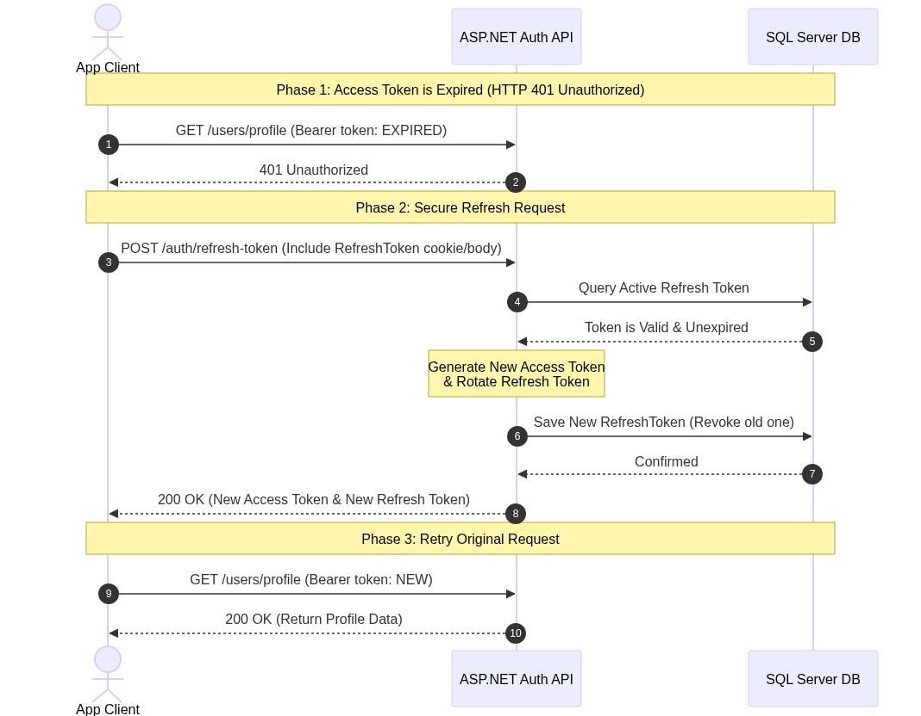
Figure A.1: Handshake flow for JWT Access and Refresh token rotation, validating security lifecycle over local endpoints.
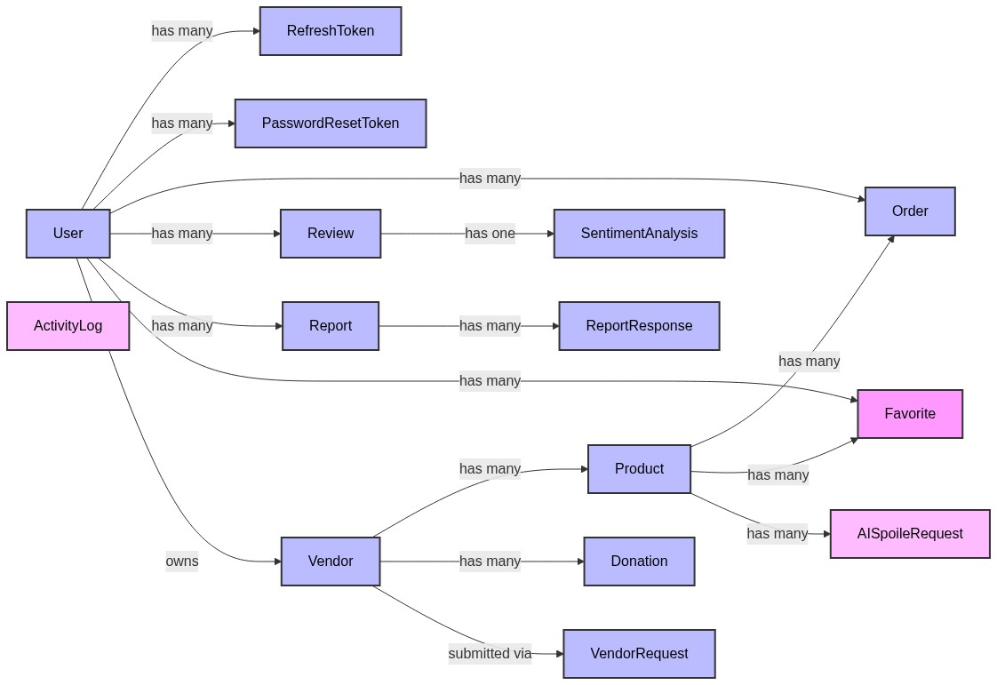 Figure A.2: Database Entity Relationship Map showing all 15 platform entities and their foreign key associations

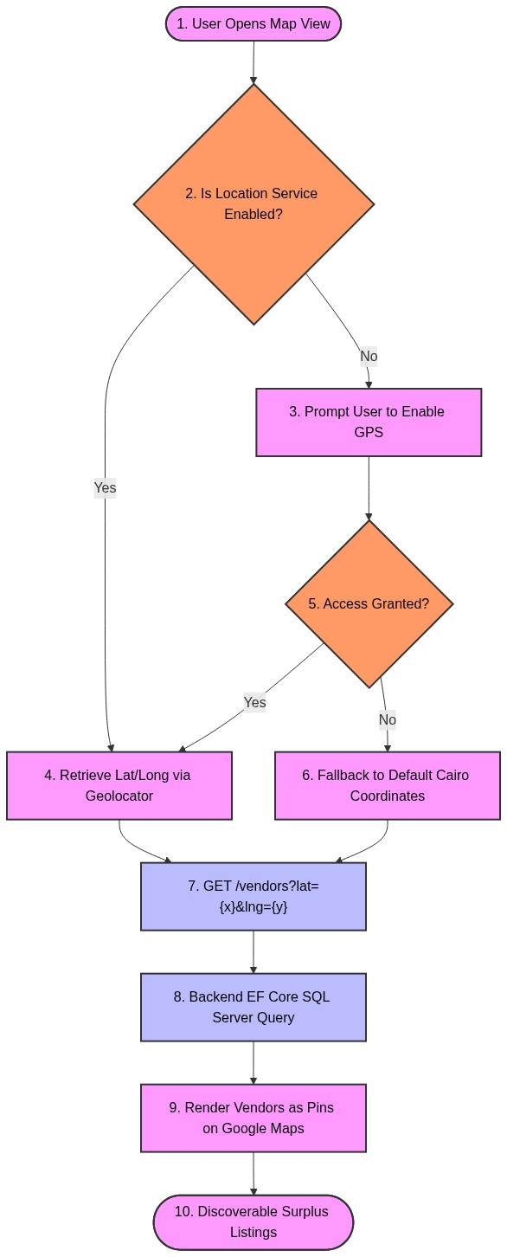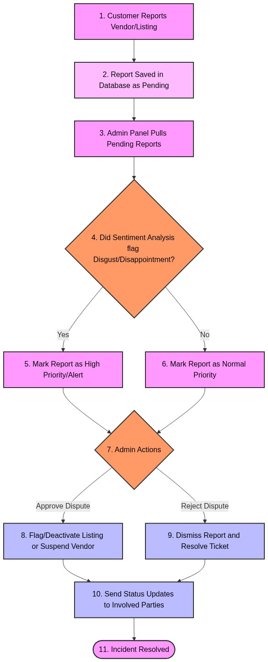
Figure A.3: Mobile interface flow mapping dynamic client coordinates queries and background error handler loops.
Figure A.4: Administrative lifecycle for content moderation using text analysis and manual confirmation.

